
LA GRANDEE INTERNATIONAL COLLEGE
Simalchaur, Pokhara Nepal
A Project Proposal
On
“Bus Reservation ”

Submitted to:
Bachelor of Computer Application(BCA) Program
In partial fulfilment of the requirements for the degree of BCA under
Pokhara University
Submitted by:
Manisha Timilsina | BCA | 2nd | 2025-1-53-0332
Prapti Ghimire | BCA | 2nd | 2025-1-53-0339
Malati B.K | BCA | 2nd
Date:02/05/2026

Acknowledgement
The satisfaction that accompanies after the successful completion of any task will be incomplete without mentioning the people whose ceaseless and relentless cooperation, constant guidance and encouragement made this project possible.
We are grateful to our project supervisor Mr Arpan Pokhrel, our faculty teacher Mr. Ramesh Chalise, for the guidance, inspiration and constructive suggestions that helped us in the preparation of this project.
We are also appreciative among each other and have understood that teamwork, the designation of the task per the skillset one portrays, constant synchronisation and monitoring of progress and instilling new knowledge and skill is imperative for the success of any given work.
Sincerely,
Manisha Timilsina
Prapti Ghimire
Malati B.k.

TABLE OF CONTENT
ACKNOWLEDGEMENT ii
STUDENT’S DECLARATION iii
SUPERVISOR’S DECLARATION iv
1. INTRODUCTION 1
2. PROBLEM STATEMENT 2
3. OBJECTIVES 3
4. METHODOLOGY 4
5. DATA FLOW DIAGRAM 5
6. PROJECT GANTT CHART/ TIMELINE CHART 6
7. DELIVERABLES 7
8. CONCLUSION 8

LIST OF FIGURES

1.Introduction
In today's modern world, transportation plays a very important role in people’s daily lives. With the rapid growth in population and urbanization, the number of passengers travelling by bus has increased significantly. Traditional manual ticket booking systems are becoming inefficient because they consume more time, create confusion in maintaining records, and often lead to human errors. Long queues at ticket counters, difficulties in checking seat availability, and problems in ticket cancellation make the manual system inconvenient for both passenger and bus operators. To overcome these limitations, computerized reservation systems have become an essential solution in the transportation sector.

The Bus Reservation System is a software based project developed to simplify the process of booking and managing bus tickets. This system helps passengers to reserve seats easily and enables bus operators to manage records efficiently. By using programming languages such as C, it is possible to create a simple, fast, and reliable reservation system that automates various operations related to ticket management. This system reduces paperwork, minimises human efforts, and improves the accuracy of information handling.

The main purpose of the Bus Reservation System is to provide a convenient and user friendly platform for booking bus tickets. Through this system, users can check available buses, reserve seats, cancel tickets, and view bus details without facing the difficulties of manual processes. This project also includes a login system that ensures only authorized users can access the application. Such a system helps in maintaining security and proper management of passenger information.

This online booking system will end the process of carrying handy tickets by conductors. They can easily register into the system and get the information of the booked ticket and also passengers can carry their ticket on their device which reduces the risk of losing tickets. This system only lets authorized users to register which will prevent loss on account of malpractice. This system will also keep the data secure in the database and those data can easily be retrieved in case of need.

This project is useful for both bus companies and passengers. For passengers, it offers convenience, efficiency, speed, and flexibility in booking tickets. They do not need to stand in long queue or depend on manual booking offices. For bus operators, the system helps to maintain record accurately and reduces the chances of data loss or booking errors. The cancellation features also allows tickets to be managed efficiently by updating seat availability automatically.
The Bus Reservation System developed in C programming focuses on implementing the fundamental concept of programming such as functions, arrays, file handling, loop, and conditional statements. This project provides practical knowledge about software development and database like record management using files. The proposed system includes several important modules such as login management, ticket booking, ticket cancellation, and checking bus status.

Another important objective of this project is to reduce the workload of manual administration. In the traditional system, maintaining passenger details manually is difficult and time consuming. There is always a possibility of duplicate booking, calculation mistakes, and loss of records. By introducing a computerized reservation system, these problems can be minimized. This project ensures proper storage and retrieval of information, making the management process easier and more efficient.

In conclusion, The Bus Reservation System is an important and useful application that helps to modernize the traditional ticket booking process. It provides an efficient, secure, and user friendly method for bus reservations. By automating tasks like booking processes, cancellation, and checking bus status, the system saves time, reduces human errors and improves overall service quality. Therefore, the development of a Bus Reservation System is educationally valuable and practically beneficial for transportation management.

Problem Statement
There were many difficulties as this was our first programming based project. Although there were many problems we were able to solve and implement it on our project. Lots of errors and many failures occur while attempting the entire task given in this project. Data collection, multiple seat booking, data was inaccurate, adaptation in the system according to government policy and organizational change were difficult in the existing system. So to overcome these difficulties our program was intended.
Many bus companies in Nepal still use manual ticket booking systems based on hand written records and paper tickets. Problems such as ticket duplication, incorrect record keeping, and loss of booking information are common in traditional systems. Managing ticket cancellation and updating seat status manually create confusion for bus operators.
List of the following issues as secondary but prominent issues can make problem statements in both micro and macro level:
- Long waiting in queue
- Difficulty of getting tickets during special occasion
- Lack of computerized system in many areas
- Overcrowding and seat unavailability
- Duplicate or incorrect booking
- Poor management of ticket cancelation
- Time consuming in manual booking
- Risk of losing ticket

Objectives
There is a need for a computerized reservation system that can automate ticket booking and record management. The increasing population and urbanization have increased the number of bus passenger significantly.
Some of the main objective of this project are:
- Provide secure user login using username and password
- Allow passenger to book and cancel bus tickets easily
- Display bus details and seat details
- Simple and user friendly menu driven interface
- Improves speed and efficiency
- Check the current status of the buses and seat available

Background Study
Transportation continues to play a vital role in the daily lives of people, especially in developing countries like Nepal where a large number of people will depend on buses for travelling from one place to another. With the continuous growth in population and urbanization, the number of passenger using public transportation is increasing significantly. As a result, traditional manual reservation systems face many difficulties in managing passenger record, ticket booking, and seat availability efficiency.

In many areas of Nepal, passengers still have to visit the ticket counter physically or contact the booking agency through phone calls to reserve seats. This process consumes time and may create inconvenience for passenger. Manual booking methods also increase the chance of human errors such as double booking, incorrect ticket entries, loss of record, and difficulty in maintaining passenger information properly.

Bus operators face challenges in handling large amount of reservation data manually. Preparing reports, checking seat availability, updating schedules, and managing costumer details become difficult and time consuming. The lack of proper digital management system may also reduce service efficiency and costumer satisfaction.

To overcome these problem, a Bus Reservation System will be developed as a computerized solution for managing bus tickets reservation and related activities. This system will help bus operators store and manage records systematically and securely. The proposed system will reduce paperwork and minimize the dependency on manual processes. It will save time for both passengers and bus operators while improving the accuracy of reservation management. The system will also help in reducing booking conflicts, maintaining proper records, and generating reports more effectively.
With the advancement of information technology, computerized reservation systems will become increasingly important in the transportation sector. Many organizations and transportation services will adopt digital systems to improve operational efficiency and provide better customer service. In the context of Nepal, implementing a Bus Reservation System will support the modernization of public transportation management and improve the travel experience for passengers.
Furthermore, the system will provide a reliable and user-friendly environment for ticket booking and management. It will increase transparency in reservation activities and help passengers access transportation services more conveniently. The development of such a system will therefore contribute to improving the quality, efficiency, and reliability of bus transportation services in the future.

Requirement Document
5.1 Functional Requirement
- Login System: The secure point where both passenger and bus operators uses passwords to enter into the software.
- Main menu: The dashboard that directs users to different services.
- Bus information management: An administrative tool to add, update, or remove bus detail.
- Ticket booking: Core process allowing user to select bus, seat, and pay for journey.
- Ticket cancellation: This feature user to cancel a booking and initiate refund.
- Log out system: this is a security function that ends the active session.

5.2 Non Functional Requirement
- Performance: Speed of the system and its ability to handle users.
- Security: Encrypting passwords and protects data.
- Reliability: Consistency of the system
- Usability: How easy and intuitive the interface is
- Maintainiability: Updating, fixing errors, and modifying the system

Use case

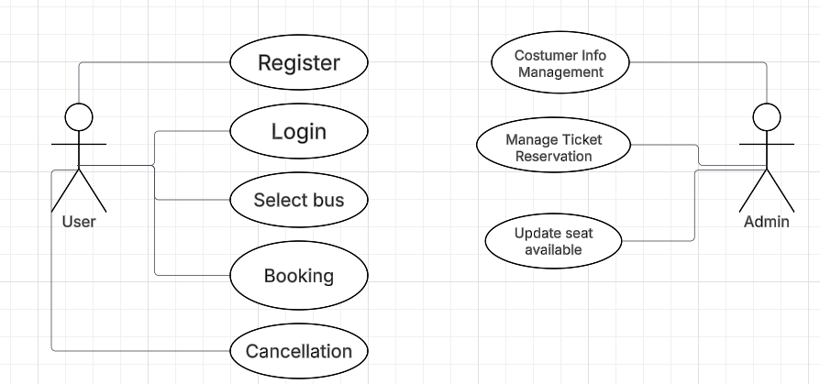

Detailed Timeline
The Waterfall model is a traditional, linear, and sequential software development life cycle(SDLC) approach where each phase, requirements, design, implementation, testing, deployment, and maintenance must be completed before moving to next step. This model is suitable for project with stable and well defined requirements.

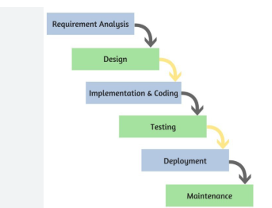

Why does the waterfall model fit this system?
- Simple and small project
- Requirement are fixed
- Simple console based system
- Easy to design step by step
- Suitable for academic project
- Sequential Development process
- Easier testing and debugging

Gantt Chart

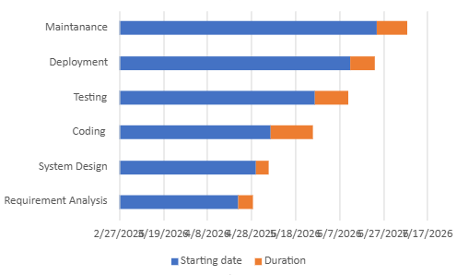

Reference

Conclusion
In conclusion, the Bus Reservation System is a useful and effective software project developed to modernize the traditional ticket booking process. The system helps to simplify bus ticket reservation, cancellation, and seat management through a computerised approach. By replacing manual methods, the proposed system reduces paper work, minimises human errors, saves time, and improves the accuracy of record management.

The project provides a user friendly and secure environment where passengers can easily book or cancel tickets and check bus detail. The login system ensure that only authorized users can access the application, which increases the security and reliability of the system. The automated management of seat availability and passenger records makes the reservation process faster, more organized, and more efficient for both passenger and bus operators.

The bus reservation system also demonstrates the practical application of C programming concepts such as structures , functions , arrays,loops,conditional statement, and file handling. Through this project , valuable knowledge about software development life cycle (SDLE) , problem solving debugging , testing, and system design is achieved . The use of the waterfall model further helps in developing the project in systematic and step by step manner .

Although the current system is console based and designed fo academic purposes, it can be improved in the future by adding advanced features such as online payment systems, database integration,real time seat selection, mobile application support, and administrator control panels. These improvements can make the system more powerful and suitable for real world transportation management .Therefore, the bus reservation system is not only educationally important but also practically beneficial. It contributes toward improving the efficiency,reliability, and convenience of transportation service while providing a strong foundation for future software development projects.

